Q11

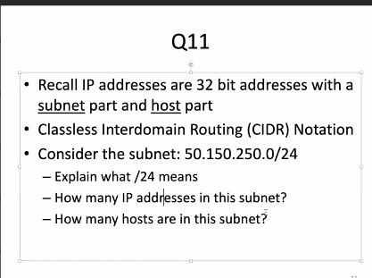

1. 24 bits to identify the subnet
2. 2^8, because there are 32-24 bits in the host part.
3. 2^8-2, because all zeros and all ones in the host part are reserved addresses.

Q12

5 subnets are in the network

Q13

(1) 206.68.144.0 is the first address, 206.68.144.1 is the first assignable address.

(2) 206.68.151.255

(3) 255.255.248.0

Q14

22 bits are same, so the CIDR aggregation is : 137.132.24.0/22

Q15

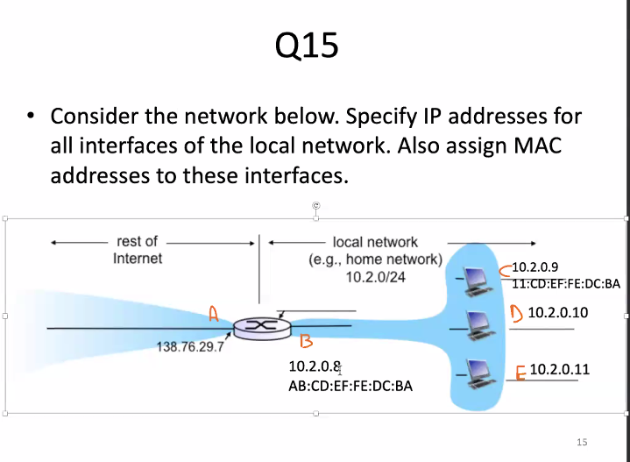

Q16

|  |  |
| --- | --- |
| WAN side address/port | LAN side address/port |
| 138.76.29.7, port 80900 | 10.2.0.9, port 7000 |
| 138.76.29.7, port 80999 | 10.2.0.10, port 7000 |
| 138.76.29.7, port 80998 | 10.2.0.11, port 7000 |
|  |  |
|  |  |